Chapter 2 homework

- Complete exercises 2.2, 2.5, 2.11, 2.12, 2.14 (replace d. with: use R to create a scatter plot with the estimated regression line, 90% C.I., bands, and 90% P.I. bands), 2.24 (only a.-c., do not do the Table 2.3 part), 2.30, 2.31 (a.-c.), and 2.64
- Examine tests from 2012
- Reproduce all examples in the notes

Partial answers:

2.2 Do on your own.
2.5
a) Here is my code and the corresponding output. Note that I edited this code and output after pasting it into Word to make it look nicer. Again, you are expected to do this as well.

> ############################################################################
> # NAME: Chris Bilder #
> # DATE: 7-19-06 #
> # PURPOSE: 2.5, 2.14 in KNN #
> # #
> # NOTES: 1) #
> # #
> ############################################################################

> #Read in the data
> copier<-read.table(file = "C:\\chris\\UNL\\STAT870\\Instructor_CD\\Data
Sets\\Chapter 1 Data Sets\\CH01PR20.txt",
header = FALSE, col.names = c("minutes", "copiers"), sep = "")
> #Check first few observations
> head(copier)
minutes copiers
1 20 2
2 60 4
3 46 3
4 41 2
5 12 1
6 137 10

> #Fit the simple linear regression model and save the results in mod.fit
> mod.fit<-lm(formula = minutes ~ copiers, data = copier)
> sum.fit<-summary(mod.fit)
> sum.fit

Call:
lm(formula = minutes ~ copiers, data = copier)

Residuals:
Min 1Q Median 3Q Max
-22.7723 -3.7371 0.3334 6.3334 15.4039

Coefficients:
Estimate Std. Error t value Pr(>|t|)
(Intercept) -0.5802 2.8039 -0.207 0.837
copiers 15.0352 0.4831 31.123 <2e-16 ***
---
Signif. codes: 0 '***' 0.001 '**' 0.01 '*' 0.05 '.' 0.1 ' ' 1

Residual standard error: 8.914 on 43 degrees of freedom
Multiple R-Squared: 0.9575, Adjusted R-squared: 0.9565
F-statistic: 968.7 on 1 and 43 DF, p-value: < 2.2e-16

> names(sum.fit)
[1] "call" "terms" "residuals" "coefficients"
[5] "aliased" "sigma" "df" "r.squared"
[9] "adj.r.squared" "fstatistic" "cov.unscaled"

> #Here are a couple ways to get the estimated Var(b1):
> # 1.
> sum.fit$coefficients #Table from summary(mod.fit)
Estimate Std. Error t value Pr(>|t|)
(Intercept) -0.5801567 2.8039411 -0.2069076 8.370587e-01
copiers 15.0352480 0.4830872 31.1232581 4.009032e-31

> sd.b1<-sum.fit$coefficients[2,2] #estimated sqrt(Var(b1))
> var.b1<-sum.fit$coefficients[2,2]^2
> data.frame(sd.b1, var.b1)
sd.b1 var.b1
1 0.4830872 0.2333733

> # 2. This uses information from Chapter 6 p. 207
> sum.fit$cov.unscaled #Estimated covariance matrix for b0 and b1 w/o MSE part
(Intercept) copiers
(Intercept) 0.09895561 -0.015013055
copiers -0.01501305 0.002937337

> var.b1<-sum.fit$cov.unscaled[2,2]*sum.fit$sigma^2
> sqrt(var.b1)
[1] 0.4830872

> #Find C.I. for beta1
> alpha<-0.1
> low<-mod.fit$coefficients[2]-qt(p = 1-alpha/2, df = mod.fit$df.residual)
*sqrt(var.b1)
> up<- mod.fit$coefficients[2]+qt(p = 1-alpha/2, df = mod.fit$df.residual)
*sqrt(var.b1)
> data.frame(b1 = mod.fit$coefficients[2], low, up)
b1 low up
copiers 15.03525 14.22314 15.84735

> #Note that mod.fit$df.residual = nrow(copier)-2 is degrees of freedom

> #To remove the "copiers" extra label in the output, use as.numeric()
> low<-as.numeric(mod.fit$coefficients[2])-qt(p = 1-alpha/2, df =
mod.fit$df.residual)*sqrt(var.b1)
> up<- as.numeric(mod.fit$coefficients[2])+qt(p = 1-alpha/2, df =
mod.fit$df.residual)*sqrt(var.b1)
> data.frame(b1 = as.numeric(mod.fit$coefficients[2]), low, up)
b1 low up
1 15.03525 14.22314 15.84735

> #Another way to get C.I.
> mod.fit$coefficients[2]-qt(p = c(1-alpha/2, alpha/2), df = mod.fit$df.residual)
*sqrt(var.b1)
[1] 14.22314 15.84735

The 90% C.I. for β₁ (change in mean service time when number of copiers increases by 1) is 14.22 < β₁ < 15.85

b) Using the output from a),

- H_{o}: β₁ = 0 vs. H_{a}: β₁ ≠ 0
- P-value is less than 2∗10⁻¹⁶
- α = 0.10
- Since 2∗10⁻¹⁶ < 0.10, reject H_{o}
- There is sufficient evidence to indicate a linear relationship between service time and the number of copiers.

c) Yes – if we would have used a C.I. for the hypothesis test instead, we would simply check whether or not 0 is in the interval. Obviously, 0 is not in the interval so we would reject H_{o}.

d) Deciding what goes in H_{o} and H_{a} is often difficult for students when performing a one-sided (one-tail) hypothesis test. The decision should center around what do you want your type I error to represent because the probability of making this error can be controlled (at α = 0.05 in this case). The copier firm wants to determine here if a standard of <14 minutes is being satisfied. Thus, they would want to control the probability of concluding <14 minutes when in fact the opposite is true. So, with the help of output in part a) and additional output,
> t.star<-(as.numeric(mod.fit$coefficients[2]) - 14)/sqrt(var.b1)
> p.value<-pt(q = t.star, df = mod.fit$df.residual) #Left tail test
> crit.value<-qt(p = 0.05, df = mod.fit$df.residual) #Left tail test
> data.frame(t.star, p.value, crit.value, df = mod.fit$df.residual)
t.star p.value crit.value df
1 2.142984 0.9810923 -1.681071 43

- H_{o}: β₁ ≥ 14 vs. H_{a}: β₁ < 14
- 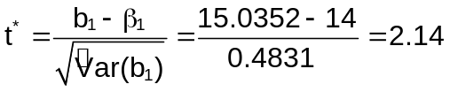
- t(0.05, 43) = -1.68
- Since 2.14 > -1.68, do not reject H_{o}
- There is not sufficient evidence to indicate the number of minutes is less than 14 for each one unit increase in the copiers.

The p-value is P(T < 2.14) = 0.9811 where T~t(43) (remember this is a left-tail test)

The answer key reverses the hypotheses to be
- H_{o}: β₁ ≤ 14 vs. H_{a}: β₁ > 14

Continuing this test produces,
- t(0.95, 43) = 1.68
- Since 2.14 > 1.68, reject H_{o} (p-value = P(T > 2.14) = 0.0189)
- There is sufficient evidence that the number of minutes is greater than 14 for each one unit increase in the copiers.

KNN probably decided to do the test this way because one would disprove the manufacturer’s claim (with a probability of 0.05 for incorrectly concluding claim is wrong). I think the problem could be worded better, and I would for a project or test. For example, to do the test that I originally did, I would have said something like “control the probability of incorrectly concluding less than 14 at a level of 0.05.”

e) No, since the number of copiers is greater than or equal to 1 throughout the data set. We can not make inferences outside of the range of our predictor variable.

2.11 Yes – see discussion in notes

  - See appropriate formulas

2.14
a)
> save.ci<-predict(object = mod.fit, newdata = data.frame(copiers = 6), interval
= "confidence", level = 0.90)
> save.ci #Part a
fit lwr upr
[1,] 89.63133 87.28387 91.9788

The confidence interval for E(Y_{h}) is 87.28 < E(Y_{h}) < 91.98. I am 90% confident that the mean time should be between 87.28 and 91.98 minutes when 6 copiers are being serviced.

b)

> save.pi<-predict(object = mod.fit, newdata = data.frame(copiers = 6), interval
= "prediction", level = 0.90)
> save.pi #Part b
fit lwr upr
[1,] 89.63133 74.46433 104.7983

The prediction interval for Y_{h} is 74.46 < E(Y_{h}) < 104.80. I am 90% confident that the time should be between 74.46 and 104.80 minutes when 6 copiers are being serviced.

c)

> save.ci[,2:3]/6 #Part c
lwr upr
14.54731 15.32980

The confidence interval is (14.55, 15.33). I am 90% confident that the mean time per copier should be between 14.55 and 15.33 minutes when 6 copiers are being serviced.

d)
#C.I. and P.I. bands plot for my part d
plot(x = copier$copiers, y = copier$minutes, xlab = "Number of copiers", ylab =
"Minutes spent by service person", main = "Minutes spent vs. Number of
copiers", col = "black", pch = 1, cex = 1.0, panel.first = grid(col =
"gray", lty = "dotted"))
curve(expr = predict(object = mod.fit, newdata = data.frame(copiers = x)),
col = "red", lty = "solid", lwd = 1, add = TRUE, from =
min(copier$copiers), to = max(copier$copiers))
curve(expr = predict(object = mod.fit, newdata = data.frame(copiers = x),
interval = "confidence", level = 0.90)[,2], col = "darkgreen", lty =
"dashed", lwd = 1, add = TRUE, from = min(copier$copiers), to =
max(copier$copiers))
curve(expr = predict(object = mod.fit, newdata = data.frame(copiers = x),
interval = "confidence", level = 0.90)[,3], col = "darkgreen", lty =
"dashed", lwd = 1, add = TRUE, from = min(copier$copiers), to =
max(copier$copiers))
curve(expr = predict(object = mod.fit, newdata = data.frame(copiers = x),
interval = "prediction", level = 0.90)[,2], col = "blue", lty = "dashed",
lwd = 1, add = TRUE, from = min(copier$copiers), to = max(copier$copiers))
curve(expr = predict(object = mod.fit, newdata = data.frame(copiers = x),
interval = "prediction", level = 0.90)[,3], col = "blue", lty = "dashed",
lwd = 1, add = TRUE, from = min(copier$copiers), to = max(copier$copiers))
legend(locator(1), legend = c("Sample model", "95% C.I.", "95% P.I."), col =
c("red", "darkgreen", "blue"), lty = c("solid", "dashed", "dashed"), bty =
"n", cex = 0.75)
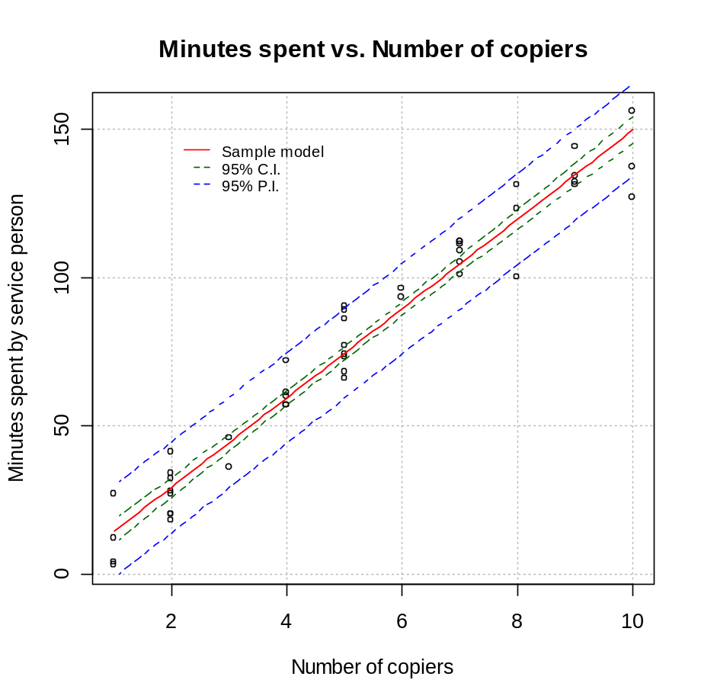

2.24
a)

> anova(mod.fit)
Analysis of Variance Table

Response: minutes
Df Sum Sq Mean Sq F value Pr(>F)
copiers 1 76960 76960 968.66 < 2.2e-16 ***
Residuals 43 3416 79
---
Signif. codes: 0 '***' 0.001 '**' 0.01 '*' 0.05 '.' 0.1 ' ' 1

SSTO = SSR + SSE = 76,960 + 3,416 = 80,376

Notice that some items are rounded in the table (compare to answer key). To match up with the answer key, you can do the following:

> anova.table<-anova(mod.fit)
> names(anova.table)
[1] "Df" "Sum Sq" "Mean Sq" "F value" "Pr(>F)"
> anova.table$"Sum Sq"
[1] 76960.423 3416.377
Notice how I used the quotation marks. This needs to be done only when parts of a list are more than one word.

- Using information from a),

  - H_{o}: β₁ = 0 vs. H_{a}: β₁ ≠ 0
  - P-value is less than 2∗10⁻¹⁶
  - α = 0.10
  - Since 2.2∗10⁻¹⁶ < 0.10, reject H_{o}
  - There is sufficient evidence to indicate a linear relationship between service time and the number of copiers.

- Coefficient of determination = R² = 0.9575 from the summary(mod.fit) output.

2.30-2.31 From the Instructor’s answer key book
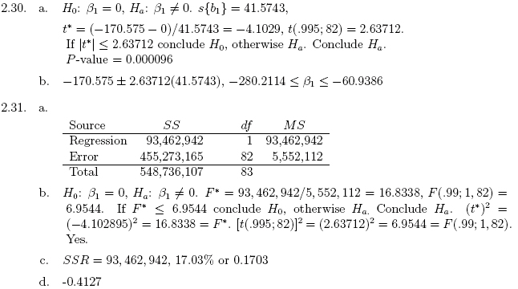

2.64 From the Instructor’s answer key book (note that r² should be R²)
